TASK # 02
Zain Ali (323)
Question 01:
FizzBuzz: print numbers 1–100; multiples of 3 print 'Fizz', multiples of 5 print 'Buzz', multiples of both print 'FizzBuzz'.
What I did:
I created a Python program that uses a `for` loop to go through all the numbers from 1 to 100. Inside the loop, I used conditional statements to check whether each number is divisible by 3, 5, or both. If a number is divisible by both 3 and 5, the program prints **“FizzBuzz.”** If it is divisible only by 3, it prints **“Fizz.”** If it is divisible only by 5, it prints **“Buzz.”** For all other numbers, the program prints the number itself.
Code :
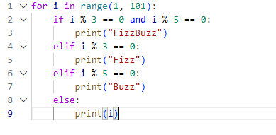
Explanation :
This code is a **FizzBuzz program**. It checks every number from **1 to 100** using a `for` loop.

- `range(1, 101)` generates numbers from 1 to 100.
- `i % 3 == 0` checks whether a number is completely divisible by 3.
- `i % 5 == 0` checks whether a number is completely divisible by 5.
- `and` means both conditions must be true.

The program works in this order:

1. If a number is divisible by both 3 and 5, it prints **“FizzBuzz.”**
2. If it is divisible only by 3, it prints **“Fizz.”**
3. If it is divisible only by 5, it prints **“Buzz.”**
4. If it is not divisible by either 3 or 5, it prints the number itself.

For example, the output will be:

```text
1
2
Fizz
4
Buzz
Fizz
7
8
Fizz
Buzz

...
FizzBuzz
```

In short, this program checks numbers from 1 to 100 and prints a specific word based on their divisibility.
Screenshot code running:
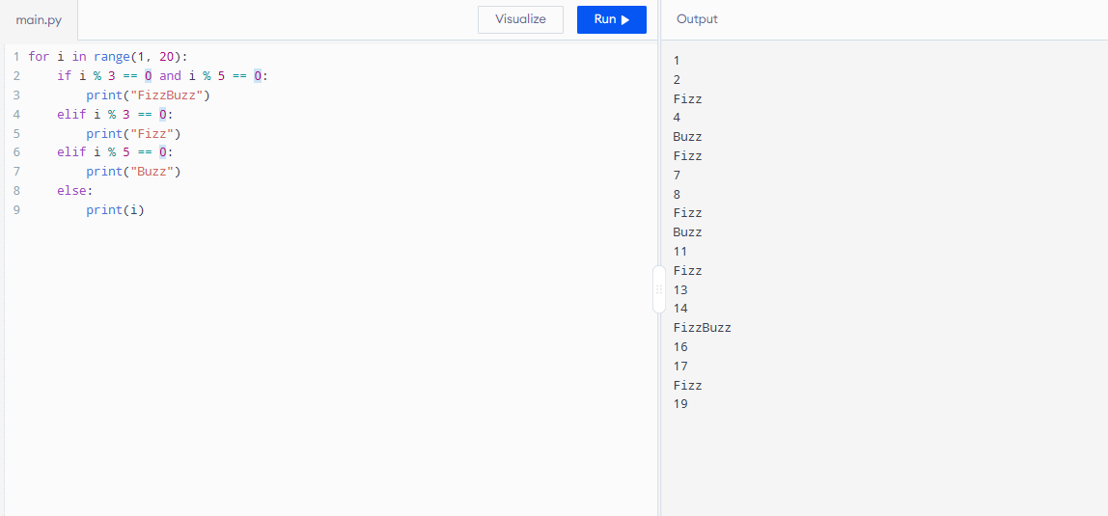
Question 02:
Movie budgets: given a list of (title, budget) tuples, calculate the average budget, print every movie above average with the amount it exceeds the average by, and count how many movies exceeded it.
What I did:
I created a Python program that stores movie titles and their budgets in a list of tuples. Then, I calculated the average budget of all the movies by adding their budgets and dividing the total by the number of movies. After that, I used a `for` loop to find and display the movies whose budgets are higher than the average budget. Finally, I counted how many movies have budgets above the average and printed the total number.
Code :
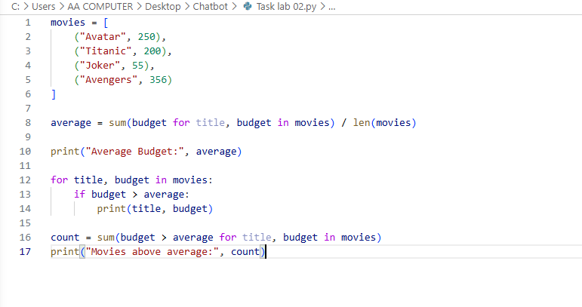

Explanation :
This code stores the names and budgets of four movies in a list called `movies`. Each movie is stored as a tuple containing its title and budget.

The program calculates the average budget by adding all the movie budgets and dividing the total by the number of movies. The average budget is **215.25**.

Then, the `for` loop checks each movie and prints the movies whose budgets are higher than the average. In this case, it prints:

```text
Avatar 250
Avengers 356
```

Finally, the program counts how many movies have budgets above the average. The result is:

```text
Movies above average: 2
```

In short, this code calculates the average movie budget, displays the movies with above-average budgets, and counts them.
Screenshot code running:
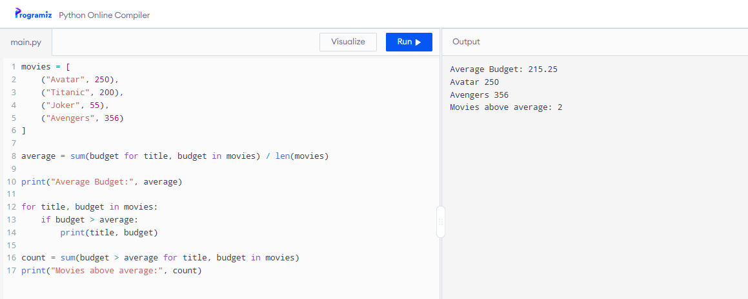

Question 03:
OOP task: write a Vehicle base class with a start_engine() method, and Car and Motorcycle subclasses that override it with their own message. Instantiate both and call the method to confirm inheritance/overriding works
What I did:
I created a Python program using **classes, inheritance, and method overriding**. First, I created a parent class called `Vehicle` with a method named `start_engine()`. Then, I created two child classes, `Car` and `Motorcycle`, which inherit from the `Vehicle` class. In both child classes, I redefined the `start_engine()` method to display a different message. After that, I created one object of the `Car` class and one object of the `Motorcycle` class. Finally, I called the `start_engine()` method for both objects, so the program prints separate messages for the car and the motorcycle.
Code :
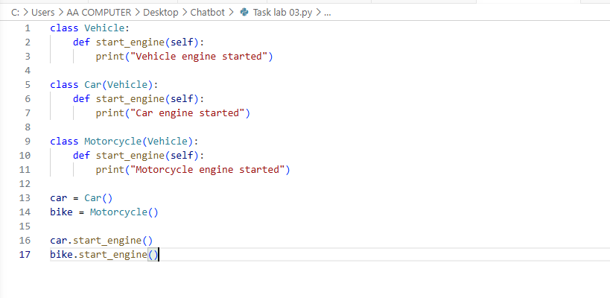

Explanation :
This code demonstrates **inheritance and method overriding** in Python.

First, the `Vehicle` class is created as a parent class. It contains a method called `start_engine()` that prints **“Vehicle engine started.”**

Next, the `Car` and `Motorcycle` classes are created as child classes of `Vehicle`. They inherit from the `Vehicle` class, but each class has its own version of the `start_engine()` method:

- The `Car` class prints **“Car engine started.”**
- The `Motorcycle` class prints **“Motorcycle engine started.”**

Then, two objects are created:

```python
car = Car()
bike = Motorcycle()
```

The `car` object belongs to the `Car` class, and the `bike` object belongs to the `Motorcycle` class.

Finally, the methods are called:

```python
car.start_engine()
bike.start_engine()
```

The output is:

```text
Car engine started
Motorcycle engine started
```

The child classes override the method from the parent class, so each object prints its own specific message.

Screenshot code running:
